Pateña, Christian Dale SJ. **CPE21S1**

**Problem 1: (Infinite Algorithm)** The problem with this algorithm is that, some of the steps appear more than once, i.e. step 5 get second number, step 7, get third number, etc.

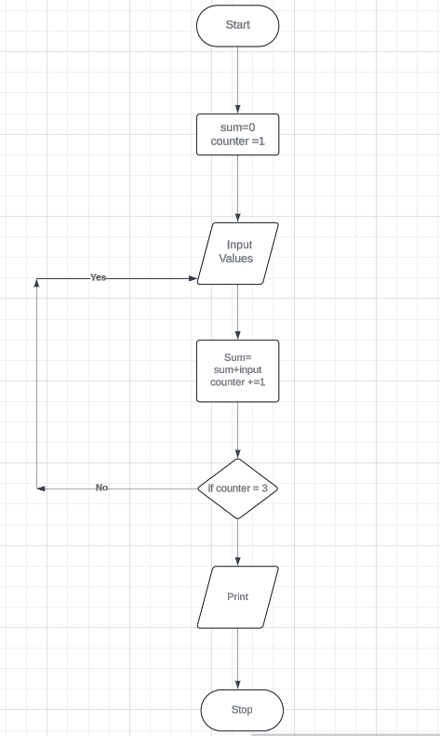

**Problem 2: (Finite Algorithm)** The new list of numbers is given as 26, 49, 498, 9387, 48962, 1, -1. The value –1 is a unique number since all other numbers are positive. This means that the procedure will stop once -1 is encountered.

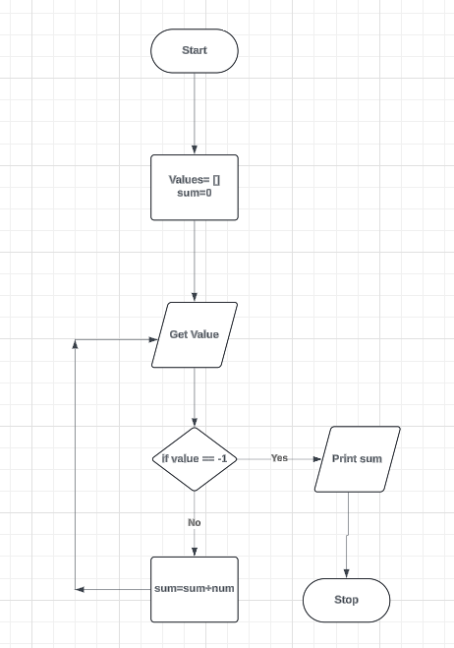

**Additional Activities:**

1. **Design an algorithm and the corresponding flowchart for finding the sum of the numbers 2, 4, 6, 8, …, n (output: Algorithm and Flowchart)**

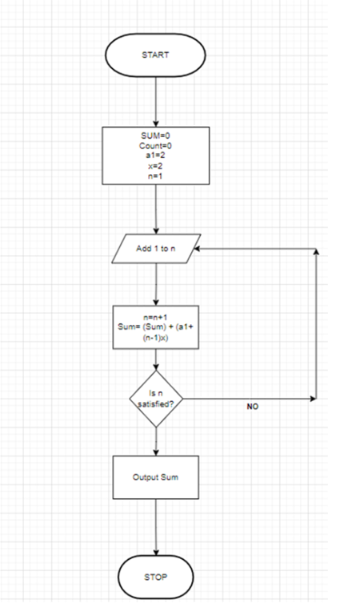

1. **Write an algorithm to read 100 numbers and then display the sum.**

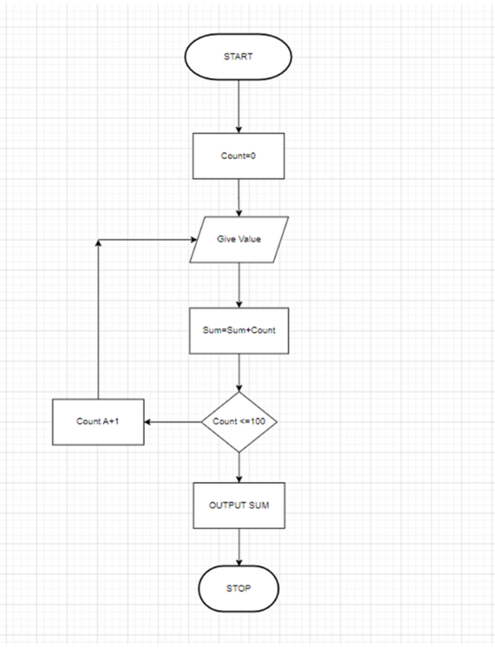

1. **Write an algorithm to read two numbers then display the largest.**

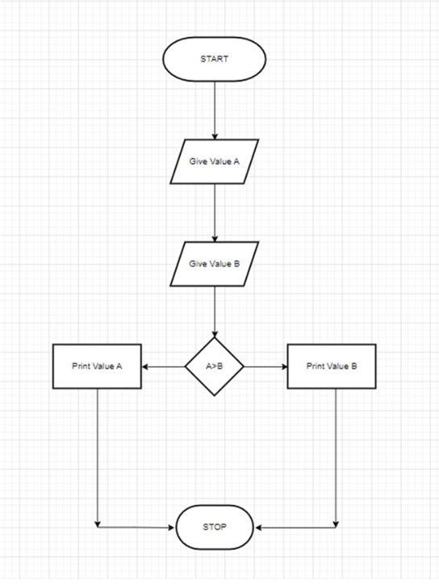

**4.)Write an algorithm to read two numbers then display the smallest**

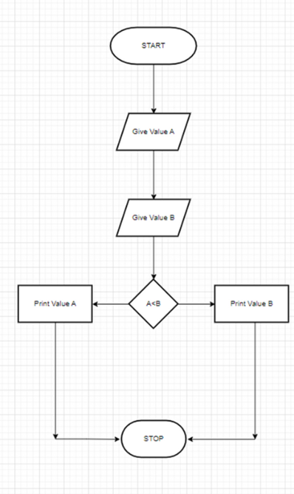

**5.) Write an algorithm to read three numbers then display the largest.**

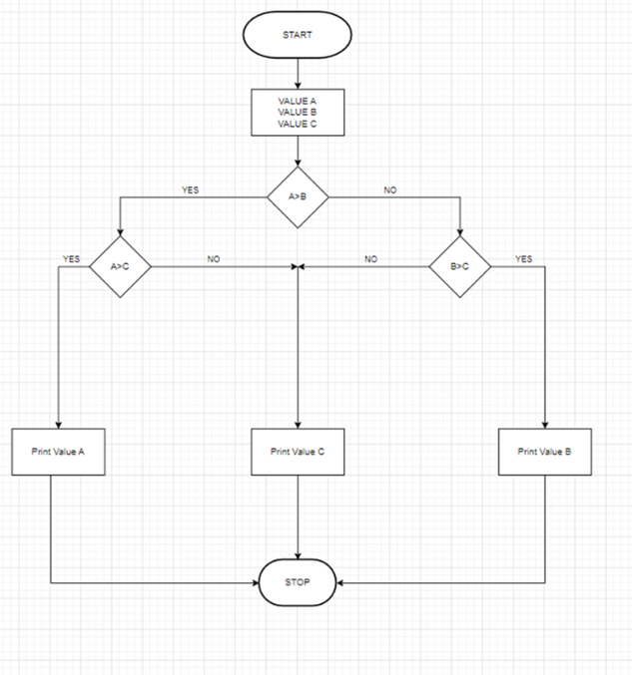

**6.) Write an algorithm to read 100 numbers then display the largest.**

